## Exercise 1.1: Recipe Book (Basic layout)

You will create a small app to view and create recipes. In this exercise we will start with creating a basic layout to view a recipe:

* Create a new project and open you layout *(activity_main.xml)*.
* In the *Text* view change the root element to *LinearLayout* and set an attribute *android:orientation=“vertical“.* The result should look similar to this:

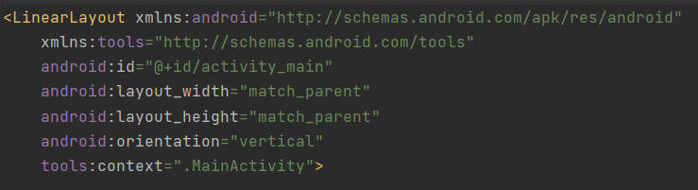

* In the *Designer* view add *TextViews* for the recipe’s name, country of origin, ingredients and instructions properties and a button to cycle through available recipes. You can also directly drag elements into the *Component Tree* if you want. The controls will automatically be arranged as a vertical list.
* Set values for initial text and an id for each of your UI elements.
* Test your layout by starting the app with the emulator or a real device.

The result can look like this (running app and component tree):

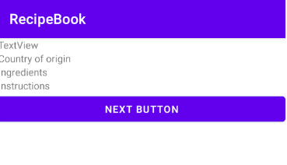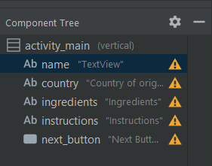

## Exercise 1.2: Add recipes to your book

In this exercise you will add a list of recipes to your book, select the first one on the list and show it in the UI from 1.1.

* Set up a class Recipe that can store a recipe name, country of origin, ingredients and instructions. Also provide a constructor and necessary methods to access the data.
* Set up a class RecipeRepository that manages a set of recipes. The class should manage the recipes in an internal ArrayList<Recipe> and have a method   
  Question getNextRecipe(Recipe currentRecipe) that finds the index of the provided recipe and returns the next one. If the current recipe is the last on the list, simply start from the first again.

The recipes themselves can be hard coded in the source code for now. For the sake of simplicity, separate the ingredients list using a comma or if you want it to be more readable using a new line(‘\n’).

* In your *Activity* initialize a RecipeRepository as an attribute and in the onCreate() method get a random question, find the TextViews and set their texts accordingly with the details of the first recipe (with index 0).

## Exercise 1.3: Add the functionality to cycle through the list of recipes

The user can go through the list of recipes by pressing the cycle button. When the button is pressed the next recipe from the list is taken from the RecipeRepository and its details are loaded into the corresponding TextViews and shown in the UI.

## Exercise 1.4: Create a more interesting UI (optional)

Play a bit with the UI settings. Try changing the properties of the TextViews and the button in order to make the activity more readable. You can try changing the text font, adding different text properties (bold, italic, etc.), adding padding and/or margin. If the content of the page becomes too big to fit on your phone’s screen, you can wrap the LinearLayout with a ScrollView to make the activity scrollable.